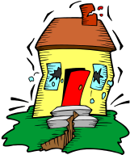
Types of Forces

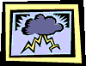
Natural forces _______ make things happen. They can move mountains ____ uproot trees. Natural forces ______ those forces which occur _____ nature without being controlled _____ influenced by people. Most natural forces play such ____ important part in ______ lives that we often take them ___ granted. We tend to only take notice ____ those natural forces that create great destruction and loss of life, _________usually occur near populated areas.
An, can, our, and, for, are, which, of, in, or.

Gravitational forces
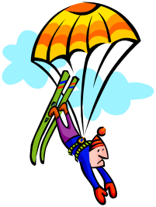
Gravitational forces ____ forces of attraction ________ objects. The Earth’s gravitational force, ____ gravity, keeps everything, including _____ and I, on _____ ground.

You, are, or, between, the

Atmospheric forces
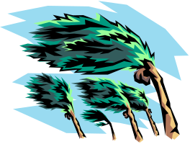
Atmospheric forces occur _____ the atmosphere. They can ______ very destructive, such as, cyclones _______ tornadoes, ____ helpful, such as thermals used ___ gliders pilots.

By, and, be, in, or

Magnetic forces

Magnetic forces occur ___ nature. Lodestones ____ magnetic. The Earth acts ____ a large bar magnet, with a north ____ south pole, producing ___ large magnetic field.

Are, a, in, and, as

Earthquakes
Earthquakes _____ violent shaking ____ movement of ____ ground. The force of an earthquake _____ cause much destruction and loss ___ life. Earthquakes can ______ cause large ocean waves _________ tsunamis.
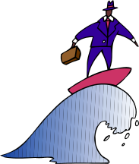

Called, are, can, of, also, the, and

